RBXFolio Audit:

All Pages:
- Use a font that suits the gaming vibe.

Home Page
- Need better logo:


- On Home page this is supposed to show user’s avatar when they login but if there isn’t a logged in user, it should show a better UI placeholder. Also the people visiting the profiles aren’t going to be logged in most likely so this is bad ui:
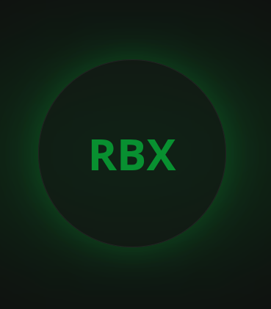

- These stats should be of real time and accurate:
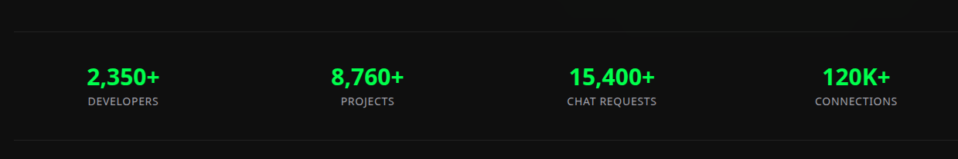
- This data should be accurate as well and the featured users should be chosen based on criteria:

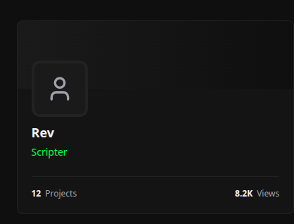

User page:
- The username’s z-index should be higher than the banner image.
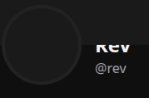

- The chat option looks like garbage:
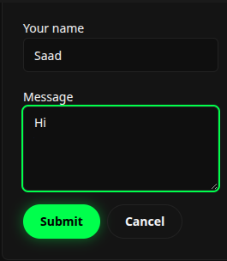

Browse Page:
- The main browse section should have matching width with the header itself for consistent design:
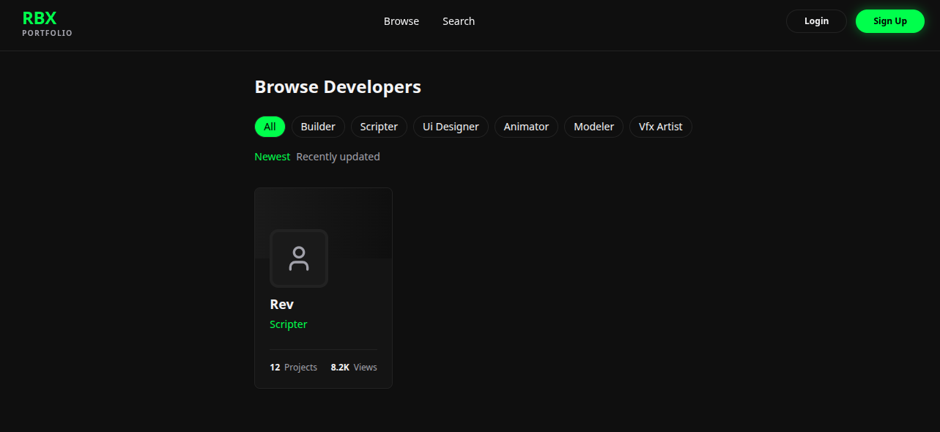
- This filtering should be on the right site of the page not left:
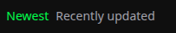

Search Page:
- The width of the section should be matching with the header:
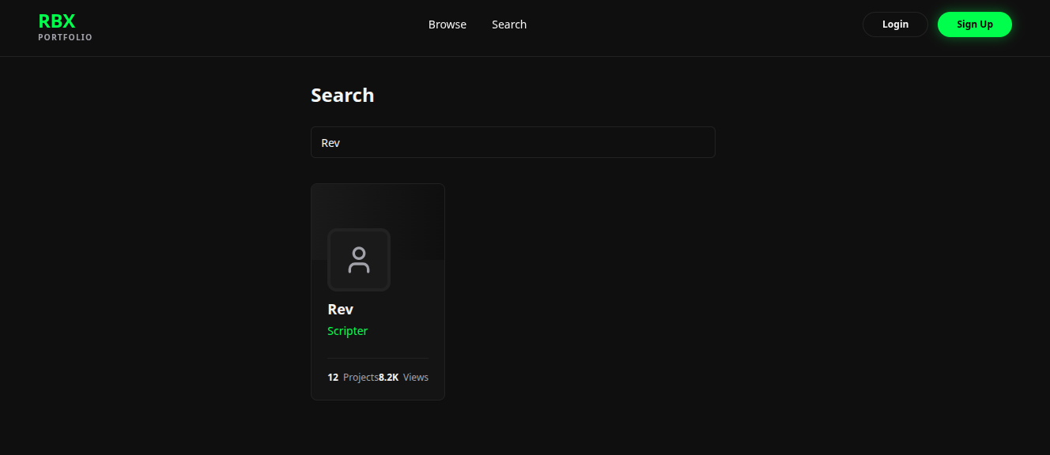

Sign In Page:
- These should have space separation between them. One to the left, one to the right:
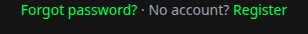

Auth pages:
- This button should have cursor pointer on hover:


- There should be spacing between the label and the input:
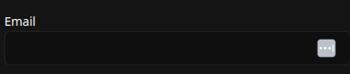

Dashboard:
- The profile page isn’t working
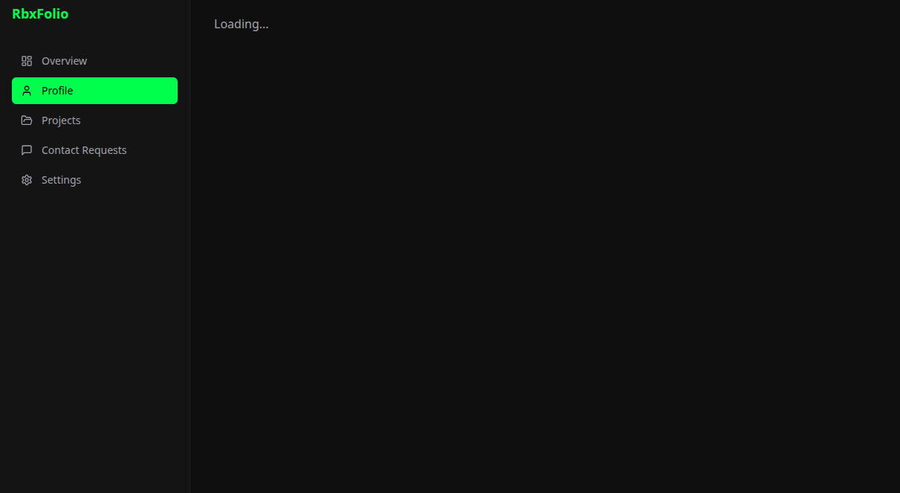
- The project details are very low, like it isn’t accounting for different types of work each role does and there are very much less fields compared to the how a portfolio project should be:
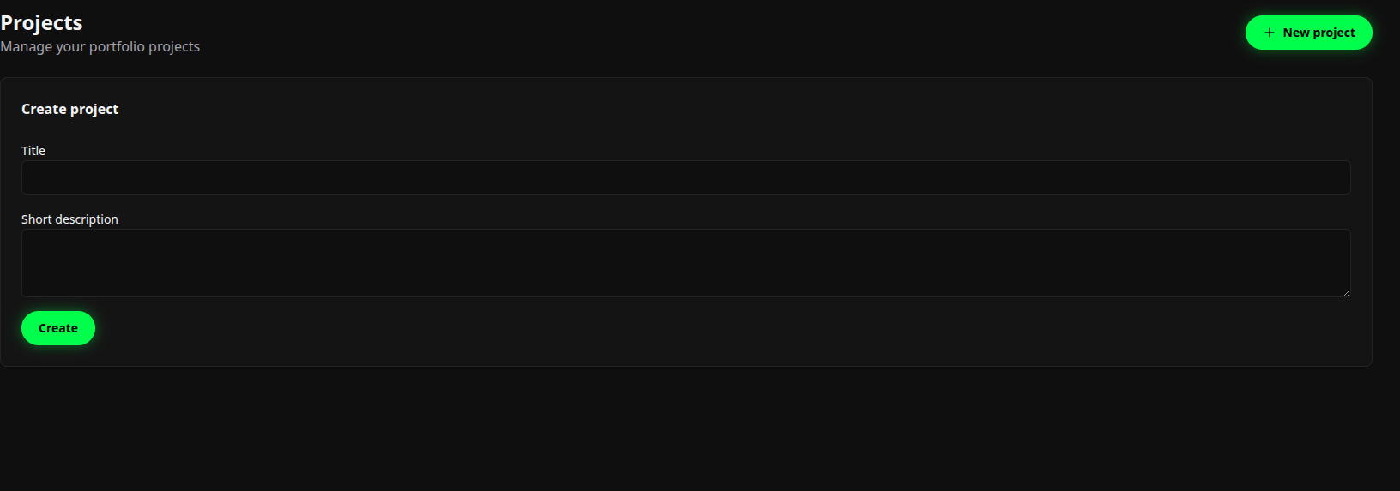
- Contact request page isn’t working:

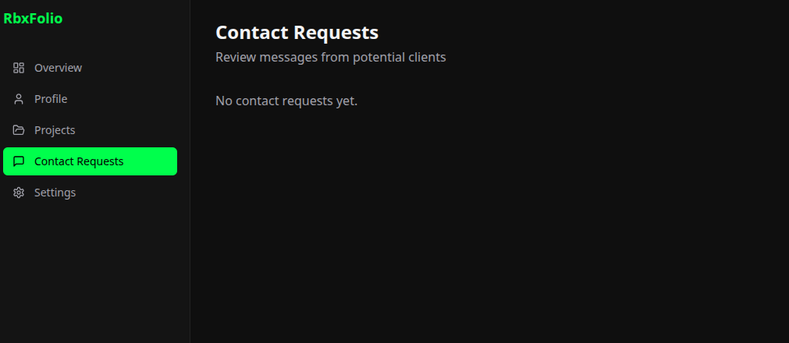
- Settings is lack luster.
